Customer Request Flow
Customers may raise a ticket requesting either:
- Confirmation of whether the MTN APN is already configured on one or more SIMs.
- Addition of the MTN APN to the SIM(s).
Required Tools
To proceed, ensure you have access to the Postman collection provided in the attachments below.
Step-by-Step Process
- Import the Postman Collection
Begin by importing the attached Postman collection into your workspace.
- Check SIM Provisioning on HLR
Before making any changes, verify whether the SIM is provisioned on the Home Location Register (HLR).
- Prepare the Request Body
  - Obtain the MSISDN (mobile number) from the customer or using VP.
  - Replace the placeholder MSISDN in the request body with the actual number.
- Submit the Query
  - Run the request in Postman.
  - The response will indicate whether the SIM is present or absent on the HLR.

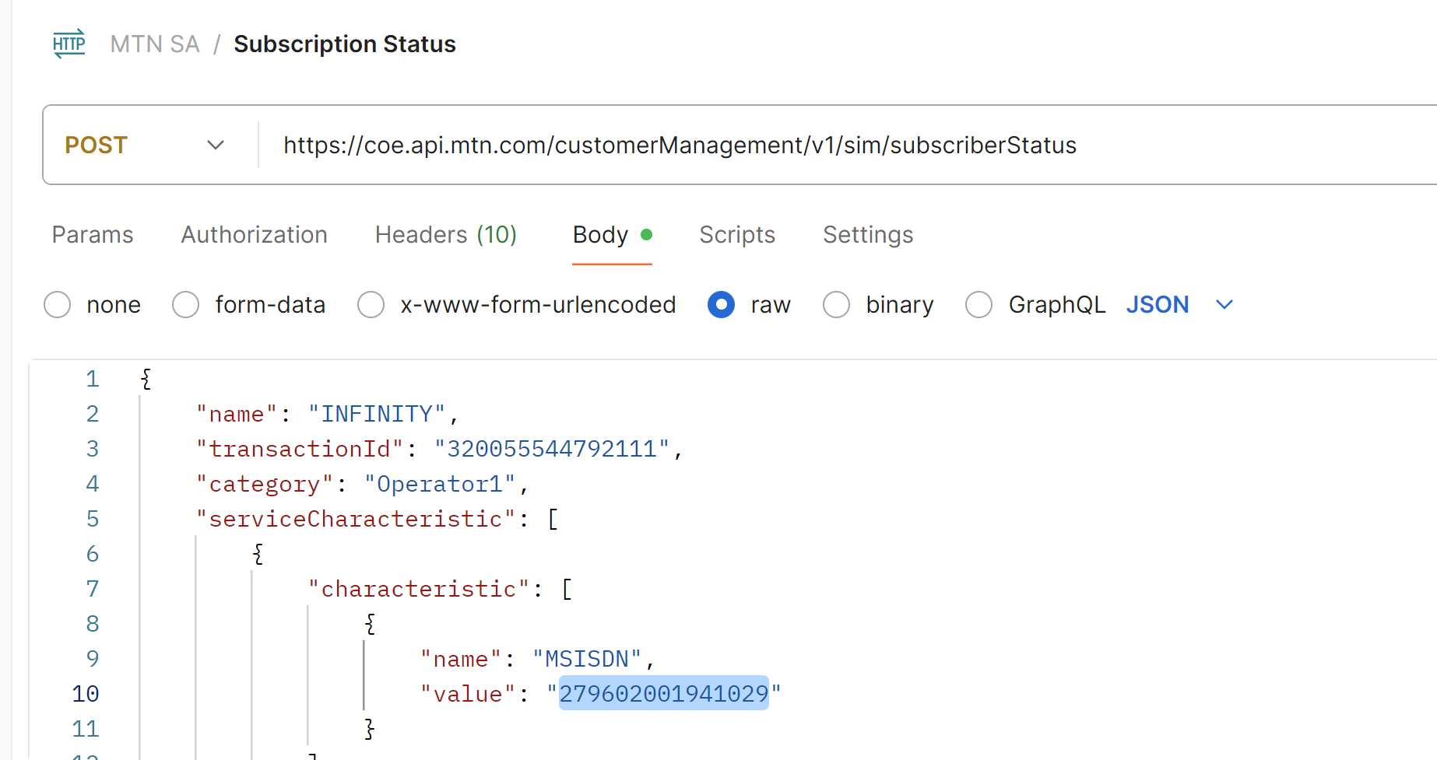

Verifying APN Details and APN ID
Once the SIM is confirmed to be present on the HLR and is in a provisioned state on our end, the next step is to verify the APN details and retrieve the APN ID.
How to Check
- Update the MSISDN in the request URL with the customer's actual number.
- Submit the request.
- The response will indicate whether the SIM has a valid APN ID assigned.

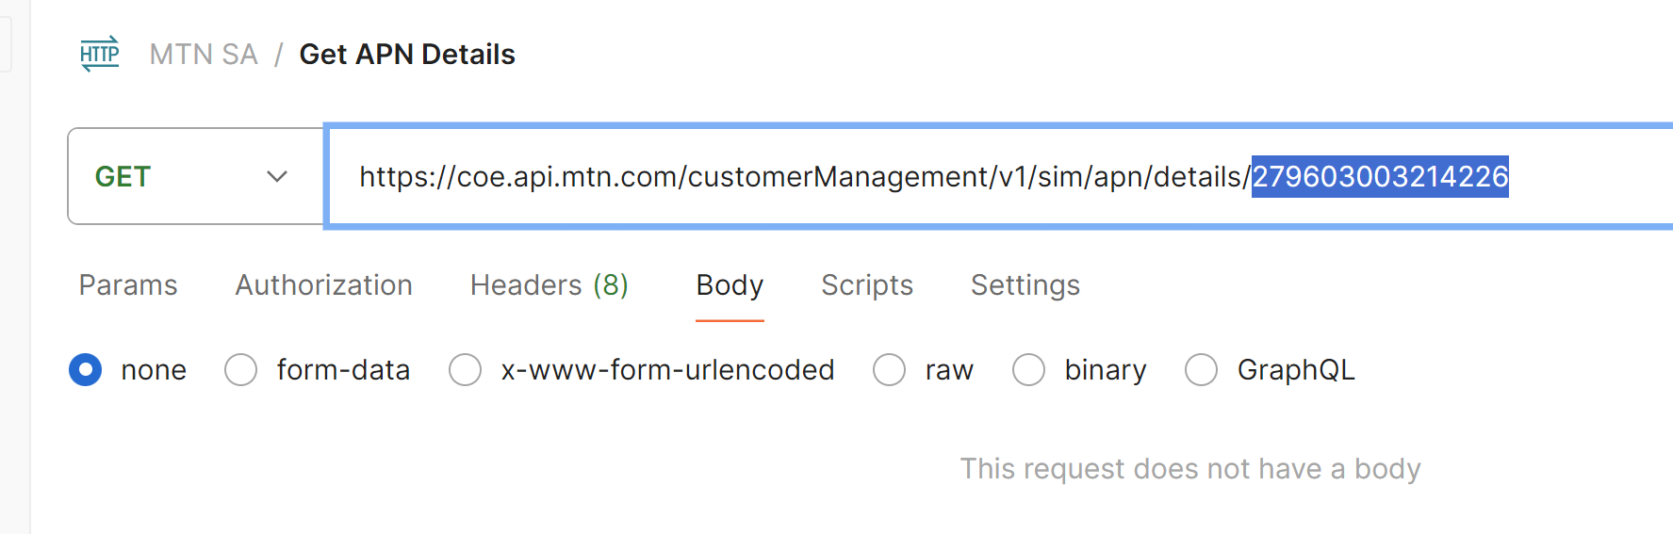

The answer for a valid APN ID will be in the screenshot below.
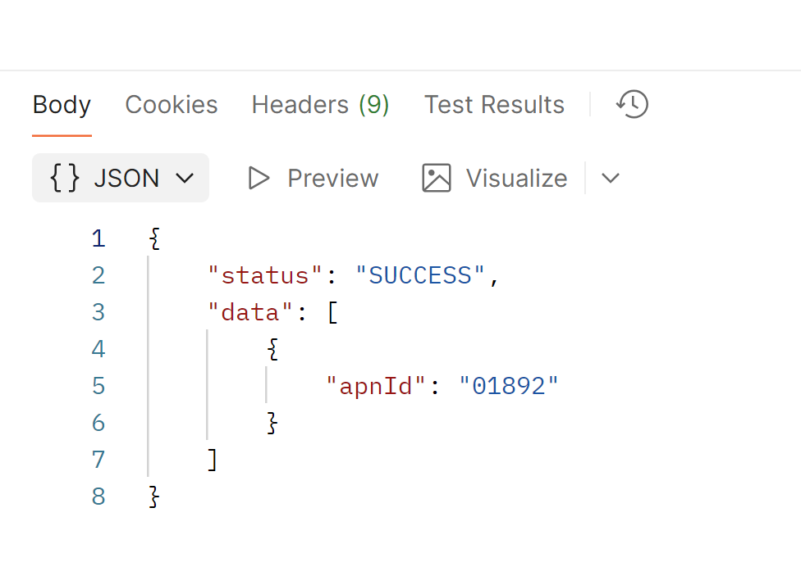

Final Validation and APN Assignment
If the response returns success and provides a valid APN ID, the process is complete.
However, if the response returns fail, and the SIM is confirmed to be provisioned both on our side and the mobile network operator’s (MNO) side, further investigation is required.
Next Steps
- Review the Provisioning Request
Check the original provisioning request details.
- Examine MNO Request and Response
Look into the MNO’s request and response logs. These often contain the APN ID assigned to the SIM.
- Assign the APN ID
Once the correct APN ID is identified, manually assign it to the SIM to complete the configuration.

Please have a look at the Query below,
SELECT * FROM provisioning.provisioningActivity65510
where ICCID = ‘ICCID IN QUESTION’

At this stage, you’ll need to examine the structure and open the value in the editor to review

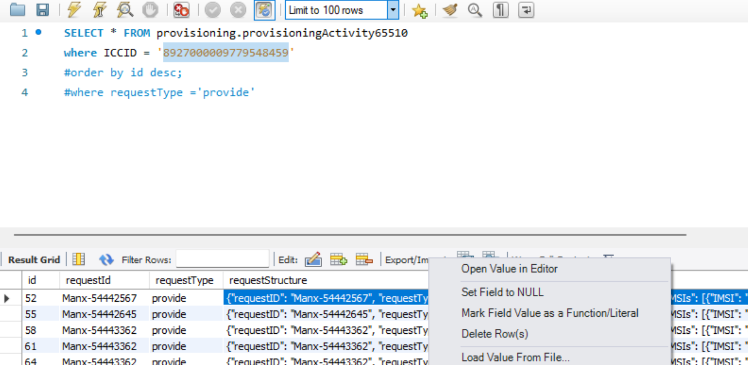

Locating and Formatting the APN ID
Scroll down within the response to locate the APN ID assigned to the SIM. Once found, copy the value.
Important Note:
When using Postman, the APN ID must be a 5-digit number.
- If the APN ID returned is only 3 or 4 digits, prepend zeroes to make it 5 digits.
  - Example: 123 → 00123
  - Example: 4567 → 04567
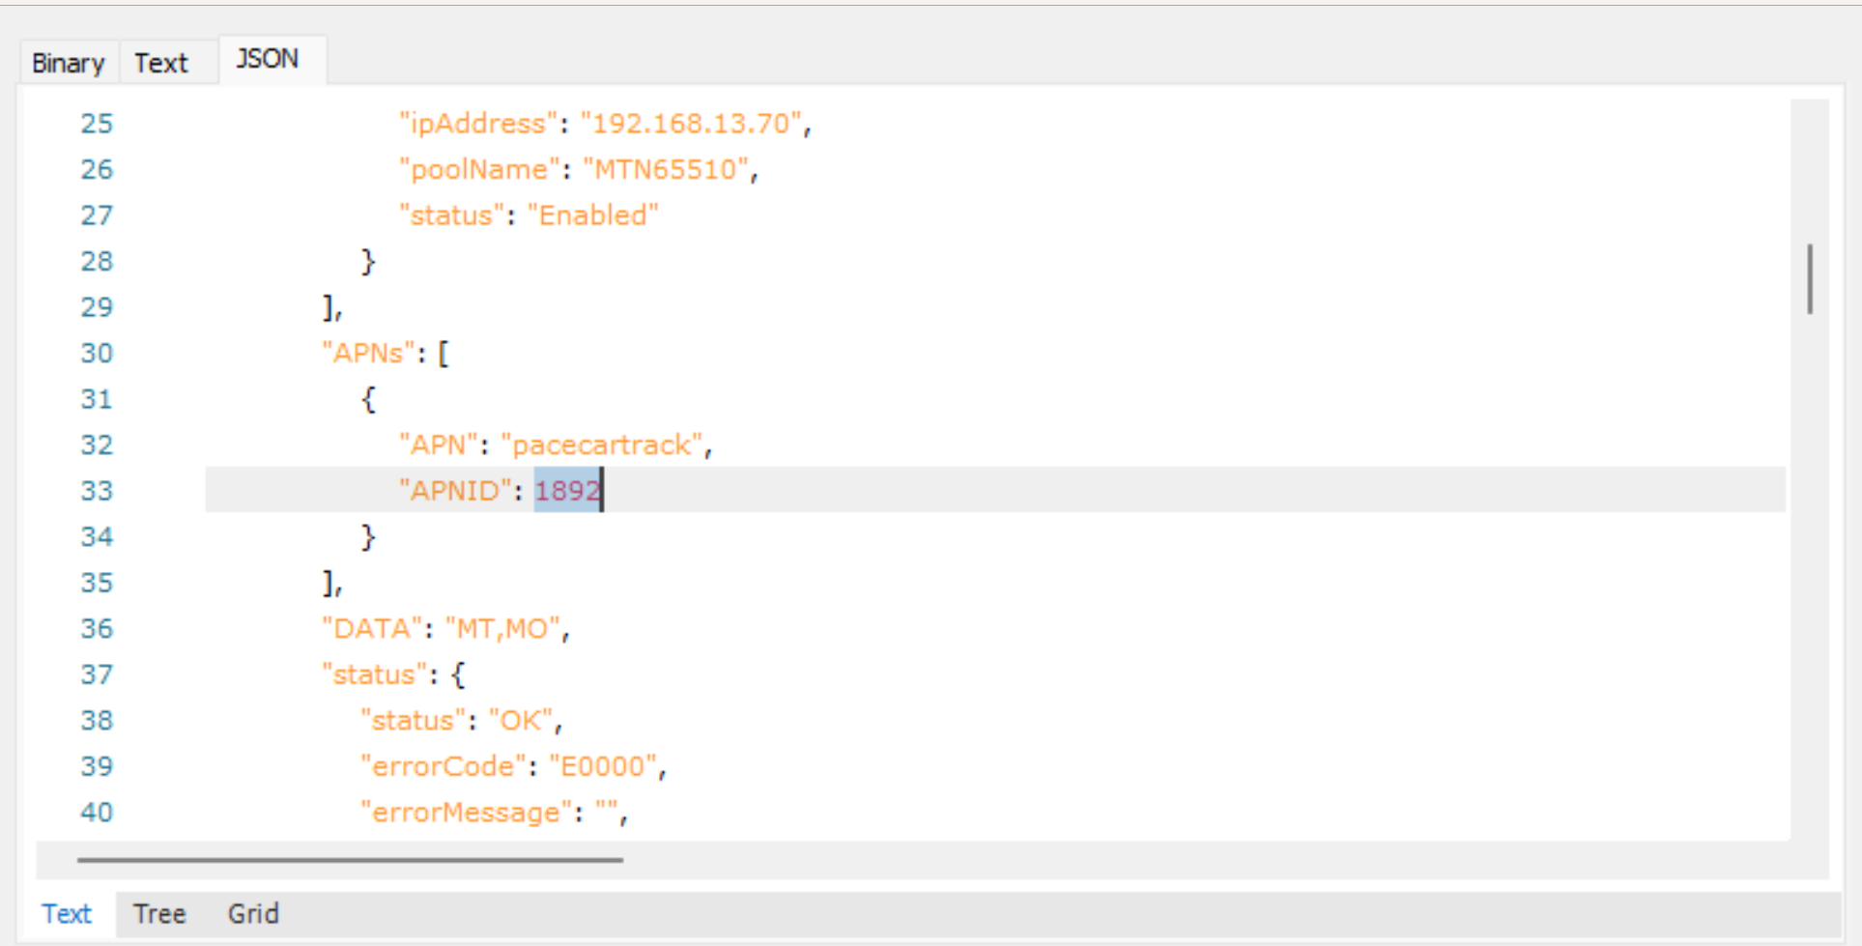

Providing the APN ID in Postman
Now that you’ve retrieved the correct APN ID, return to Postman to input and apply it.
This step ensures the SIM is correctly configured with the appropriate APN settings.
Now that you’ve retrieved the MSISDN and the corresponding APN ID from SQL, proceed to input both values into Postman as required for the next step in the configuration process.

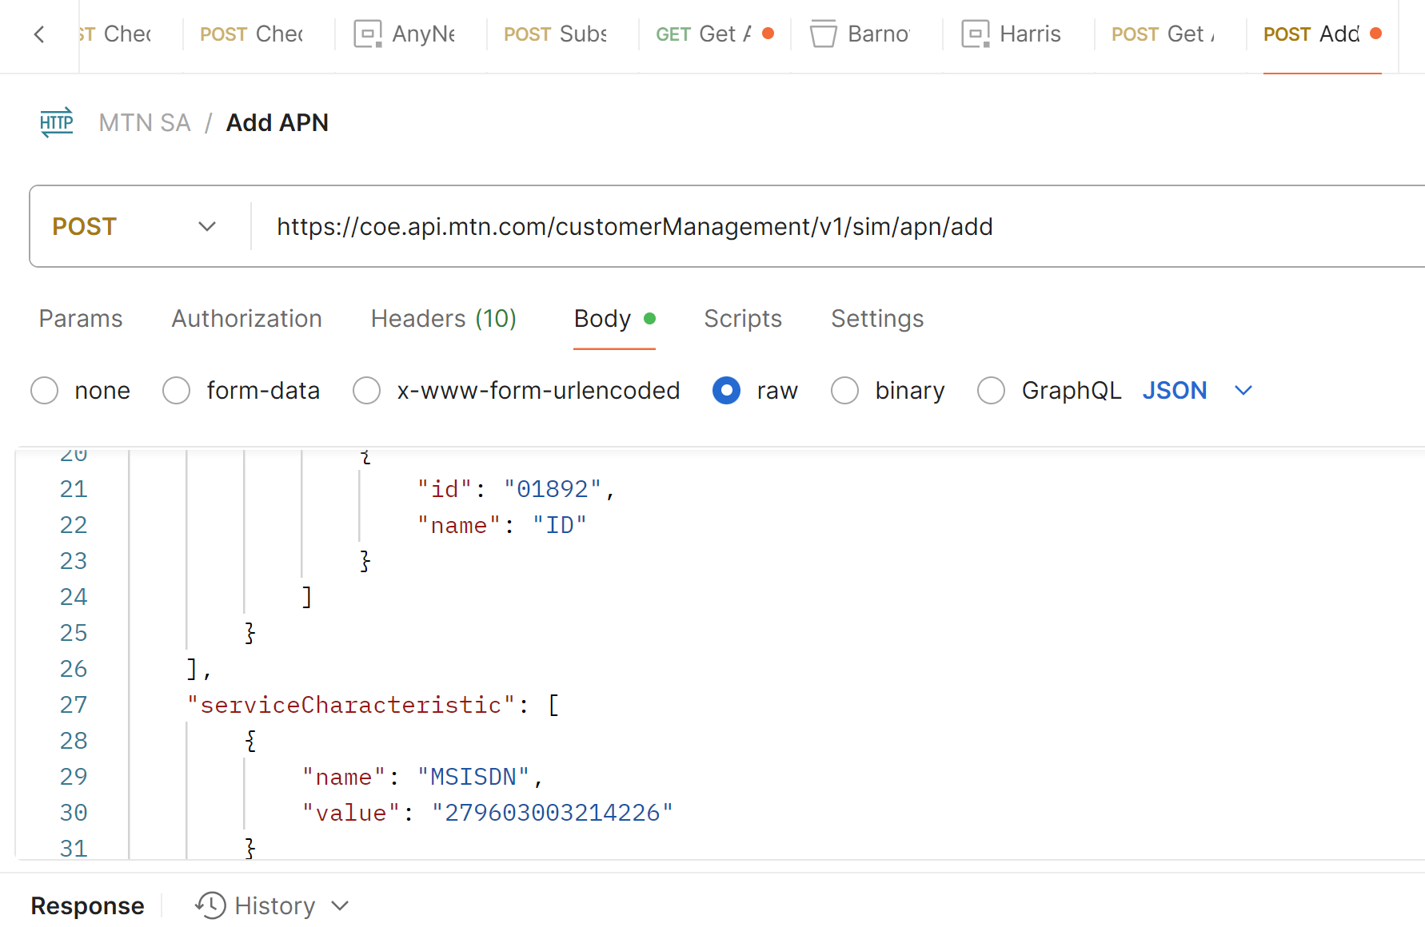

Final Submission and Verification
Once the correct APN ID has been provided in Postman, send the request and verify the response.
- If the response returns success, the process is complete.
- If the response still returns fail, despite the SIM being provisioned correctly on both our side and the MNO’s:
Escalation Steps
- Raise a ticket with the App Support team.
- Notify Vivek directly to assist with further investigation.

